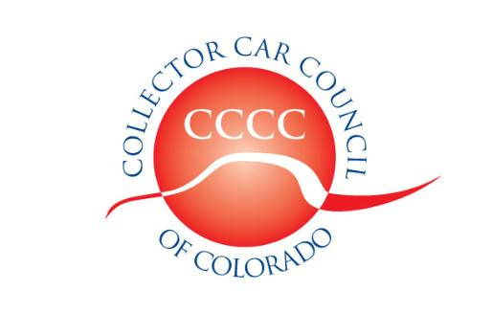

Dedicated to the preservation of automotive history

www.collectorcarcouncil.com

President: Dick Thompson, Denver Mustang Club 303-929-5533 Thompson660@cs.com
1st Vice Pres: Calvin Craig, Colorado MOPAR Club 303-668-5142 CalvinCraig@msn.com
2nd Vice Pres: John Ehrlich, ColoRODans 303-526-6805 Altechprec@yahoo.com
Secretary: Nick Lundberg, Cadillac & LaSalle Club 303-638-7017 Colorado4X4@yahoo.com
Treasurer: Samantha Baker, Southern Colorado MOPARS 303-431-1397 bakersams@msn.com
Legislative information: Leo J. Boyle 303-321-6611 Leojboyle@aol.com
Political Committee Liaison: Dick Thompson 303-929-5533 Thompson660@cs.com
Web site liaison: Ben Aycrigg, RMR AACA 303-359-1350 Baycrigg@Live.com
RMMA Car Show & Swap Meet: Rick Ruel, Cobra Club 303-919-3760 rickrule@comcast.net
SEMA Show coordinator: John Ehrlich, ColoRODans 303-526-6805 Altechprec@yahoo.com
Forney Dust n Shine coordinator: Rick Beets, RM Corsa 303-475-5366 Rick@mylifeatspeed.com

Minutes of the 3 June 2026 Meeting
The meeting was held at the Forney Museum of Transportation 4303 Brighton Blvd Denver CO. Nineteen member-club representatives, presidents, and guests were signed in. Officers present were Dick Thompson, President; John Ehrlich, 2nd Vice President; Calvin Craig, 1st Vice President; Nick Lundberg, Secretary; and Samantha Baker, Treasurer.
The meeting was called to order, with welcome and introductions, by the club President at approximately 7:31 pm.
Minutes of 1 April Meeting: A motion to accept, was seconded, and approved as presented. (there was no May club meeting as the May 6th meeting was cancelled due to weather concerns)
Legislation: Leo Boyle, the CCCC lobbyist, reported that Colorado Legislative session ended on May 13th. The upcoming political primary election is on June 30th with ballots dropping on June 8th. The CCCC political action committee (PAC) has approx. 7k in funds to possibly distribute to legislators once those legislators are determined after the primary. Leo Boyle to meet with potential recipients.
Treasurer’s Report. A motion to approve the treasurer report as presented was moved and seconded. Forty-One clubs have renewed/joined for 2026 as of end of May 2026. As it stands right now for 2026 there are Forty-One clubs, two individual membership and three Associate memberships. There are nine clubs that have not renewed as of yet for 2026, some of those clubs were mentioned; Denver Mustang, FOMOCO, Military Vehicle, RM Performance Mopar, Triumph, Rolls Royce, Sabers.. FYI, there were fifty member clubs, four individual memberships, and five associate memberships in 2025.
2026 CCCC Car Show and Swap Meet: Rick Ruel discussed needing volunteers. Discussion about food vendors, and passenger buses. Club sponsorships in the car show program are available for $100, which includes a ¼ advertisement in the brochure for the car show. Please consider volunteering to help with the car show.
Open roundtable discussion: John Ehrlich resigned the CCCC and the ColoRODans club will not be renewing membership (which would mean that there is a Vice President vacancy in CCCC governing body). The Alan Eber Estate donated $1000 to the CCCC, Alan passed away last year, per his daughter Jennifer, there will be a celebration of life on July 11th 2026. The Tebow “invite only” car event had a large Corvette presence. The Forney Dust n shine slots are all filled for 2026. The order for CCCC polo shirts was cancelled due to cost issues. Discussion topics included the Minnesota Classic car bill, Leno’s Law topics, aftermarket exhaust, tire restrictions and other car hobby restrictive wackiness.
Next meeting: Next meeting will be Wednesday, July 1st 2026, at 7:30 pm. At the Forney Museum of Transportation 4303 Brighton Blvd Denver CO. Need location for the September and October CCCC meetings, please investigate ideas and locations.
Upcoming Events: Various shows and events happening on 6/6, 6/7, and 6/12 were discussed Please see the CCCC website (collectorcarcouncil.com) for a list of upcoming car related events. The email blast list from Coloradocarsandcoffee.com is also a good resource for upcoming car related events. As is Colorado Car Shows (Calendar and Events) on Facebook. The Golden Cruise is the 1st Saturday of every month here on out through October. There are numerous Friday and Saturday Evening cruise-in type events each week throughout the spring and summer up and down the front range and in other parts of the state.
Meeting was adjourned at 8;24 pm.
Please let me of any name and spelling corrections needed
Submitted by Nicholas Lundberg, CCCC secretary
A

